Theoretical Investigation of Dosimeter Accuracy for Linear Energy Transfer Measurements in Proton Therapy: A Comparative Study of Stopping Power Ratios
Johnpaul Mbagwu𝟏,𝟐
Department of Physics and Astronomy, University of Kansas, Lawrence, KS, 66045, US𝑨𝟏
University of Kansas, School of Medicine, Kansas City, KS 66160, US𝑨𝟐
Email: mbagwujohnpaul@ku.edu

Abstract
Background: Accurate measurement of linear energy transfer (LET) is crucial in medical physics, particularly for proton therapy dosimetry. High atomic-number ($Z_{eff}$) materials such as BaFBr and low-$Z_{eff}$materials such as ${Al}_{2}O_{3}$ and water are commonly used in dosimeters.
Purpose: To evaluate the feasibility and accuracy of the use of various dosimetry materials (water, air, ${Al}_{2}O_{3}$, aluminum (Al), BaFBr, and oxygen) for measuring LET by comparing their stopping power (ratios) via the Bethe-Bloch theory and semiempirical models.
Methods: Stopping power ratios were calculated via the PSTAR database for proton energies ranging from 0.01 MeV to 10,000 MeV. The Bethe-Bloch theory with density and shell corrections was used for high-energy protons, whereas a semiempirical model was applied for low-energy protons. Calculations validation involved comparing the computed stopping powers SRIM-2008 and PSTAR for materials such as water, aluminum, air, ${Al}_{2}O_{3}$, BaFBr, and oxygen.
Results: The stopping power water-to-air ratio remains stable, while the ${Al}_{2}O_{3}$-to-water and air-to-water ratios highlight their differing attenuation properties. The BaFBr-to-water ratio shows significant material-dependent differences, and the water-to-${Al}_{2}O_{3}$ ratio is particularly relevant for proton therapy dosimetry calculations in medical physics. These results demonstrate consistency across materials but do not inherently confirm the accuracy of LET measurements. However, a comparison of theoretical models with computed stopping powers SRIM-2008 and PSTAR showed strong agreement, particularly for high-energy protons where the Bethe-Bloch theory was applied, suggesting that the models reliably predict stopping power at these energy levels.
Conclusions: This study confirms the feasibility of using high-$Z_{eff}$ materials such as BaFBr and low-$Z_{eff}$materials such as ${Al}_{2}O_{3}$ and water for the use of LET measurements in proton therapy. The results validate the use of the Bethe-Bloch theory, computed stopping powers and semiempirical models in dosimetric applications, enhancing the precision of LET measurements and contributing to improved radiation therapy outcomes.
Keywords: Linear Energy Transfer, Dosimetry, Bethe-Bloch Theory, Proton Therapy, Stopping Power, PSTAR

1. INTRODUCTION
In the field of medical physics, precise dosimetry is essential for the effective application of proton therapy. Dosimeters that measure LET accurately are critical for ensuring that the correct dosage is administered to patients. This study focuses on evaluating the use of dosimeters made from materials with different $Z_{effs}$ and uses theoretical and computed stopping powers to assess their performance.
In recent years, interest in both theoretical and experimental studies of the stopping power and particle range of various materials has increased. Charged particles lose energy through constant collisions when they contact matter. The stopping power is determined by the particle's type and energy, as well as the characteristics of the substance it travels through. The material's stopping power is related to the ionization density along the path since creating an ion pair requires a specific amount of energy. The stopping power refers to the material's characteristics, whereas the energy loss per unit path length is related to the particle's interactions.
An accurate understanding of the stopping powers of different materials is crucial for radiation dosimetry calculations, radiation quality evaluations, and modeling of energy deposition patterns. To incorporate fresh experimental data and refinements in analytic methods, stopping power data must be reviewed on a regular basis. In addition, calculating the radiation dosimetry at which ionizing particles deposit requires stopping powers. Most recent proton dosimetry protocol establishes a standard for proton dosimetry and addresses dosimetry for ions heavier than protons (International Atomic Energy Agency's (IAEA) (TRS-398), 2000).
Linear energy transfer (LET) is crucial for assessing biological efficacy and radiation quality and is tied to both unconstrained and restricted electronic stopping powers. An accurate understanding of energy loss mechanisms and rates in diverse materials is essential for determining the impact of radiation on biological systems and improving therapeutic regimens. For high energies (above 1 MeV for protons and 10 keV for electrons), Bethe's stopping-power theory is recommended for determining the collision stopping power (Bethe, 1933). This theory relies on the mean excitation energy, which is difficult to estimate theoretically for complex materials and requires experimental input.
At energies below 100 keV/nucleon, Bethe theory is less effective, making experimental data the main source, although it is often insufficient or inconsistent. Empirical fitting formulas such as Andersen-Barkas and Ziegler's shell corrections are used to extrapolate data. Computed stopping powers are available for elemental targets from PSTAR and SRIM (2008) but not for complex materials.
Bragg's rule helps estimate the stopping power of compounds and mixtures via constituent element data, simplifying computations. BaFBr is a promising detector material for high-LET radiation because of its strong radiation hardness and quick scintillation response, making it suitable for high-precision dosimetry applications (Woody, 1992).
Previous studies have explored various storage phosphor materials for dosimetry ranging from high atomic number (high-$Z_{eff})$materials such as ${BaFBrI:Eu}^{2+}$ to low-$Z_{eff}$materials such as ${KCI:Eu}^{2+}$, their study suggests that the high-$Z_{eff}$ storage phosphor could be used in conjunction with a low-$Z_{eff}$ ${KCI:Eu}^{2+}$ for linear energy transfer (LET) and simultaneous proton dose measurements (Setianegara et al., 2021). However, a study by (Setianegara et al., 2020) has shown that the essential optical and dosimetric properties of europium-doped potassium chloride (KCL) as a storage phosphor can be characterized for precise proton dosimetry, and its dose radiation response can be effectively modeled using an analytical radiation transport model. It is important to use Monte Carlo (MC) methods to model ${KCI:Eu}^{2+}$ point dosimeters and to investigate the dose responses of two-dimensional (2D) ${KCI:Eu}^{2+}$ storage phosphor films (SPFS) (Zheng et al., 2010).
In addition, other authors attempted to create 2D ${KCI:Eu}^{2+}$ storage phosphor films (spfs) via physical vapor deposition (PVD) and tape casting (Li et al., 2014). A recently proposed storage phosphor material for radiation dosimetry investigates the radiation hardness of europium-doped potassium chloride (${KCI:Eu}^{2+})$ (Driewer et al., 2011). However, (Han et al., 2009) proved that ${KCI:Eu}^{2+}$ dosimeters possess many preferable dosimetric features, which are favorable for radiation therapy dosimetry. A recent review investigated how gel dosimetry can be used in low energy procedures like radiotherapy and interventional radiology (Alyani et al., 2022). The precision of LET measurements using a low-$Z_{eff}$ material such as ${Al}_{2}O_{3}$:C OSLDs in proton beams by utilizing current, automated readers capable of conducting POSL measurements and irradiation (Christensen et al., 2022). In addition, (Granville et al., 2014) demonstrated and assessed the feasibility of calibrating ${Al}_{2}O_{3}$:C OSLDs for LET measurements using novel approaches.
Recent research has updated effective energies for reducing range error in proton treatment and ion beam therapy using helium, carbon, oxygen, and neon ions, as well as elemental values I (Inaniwa et al., 2023). They evaluated the impact of these updates on the stopping power ratio (SPR) estimation in computed tomography-based treatment planning (Inaniwa et al., 2023). The modifications increased stopping power ratios (SPRs) in soft tissues by up to 0.5% and decreased stopping power ratios (SPRs) in bone tissues by up to 1.9% compared with existing clinical settings (Inaniwa et al., 2023). An analysis of the efficacy of spectral computed tomography (CT) employing a fast kV-switching dual-energy technique to predict the stopping power ratio (SPR) for proton radiotherapy was conducted (Xu et al., 2022).
Therefore, (Liu et al., 2022) has used an experiment to confirm Geant4's proton physics models (version 10.6). Eleven different inserts, consisting of acrylic, delrin, high-density polyethylene, and polytetrafluoroethylene, were examined to determine their stopping power ratios (SPRs) using a superconducting synchrocyclotron, which produces a scattering proton beam (Liu et al., 2022). On the contrary, research on dosimetry in the low-energy range employed in clinical settings for diagnostic or therapeutic purposes has disclosed various methods rooted in fundamental quantum mechanics that can be advantageous for handling low-energy interactions (Massillon-JI et al., 2021). In the realm of medical physics, precise electronic stopping power data are of paramount importance for computing radiation-induced consequences in a multitude of proton therapy dosimetry applications, as previously documented (Akbari et al., 2023; Paul et al., 2013; Trujillo-Lopez et al., 2019; Usta et al., 2017). These studies have provided foundational knowledge on the stopping powers and ratios of these materials across different energy ranges.
1.1 Importance of Proton Therapy in Dosimetry Research
Proton therapy has been chosen as the focus of this study due to its unique advantages in delivering targeted radiation treatment, particularly for cancer patients. Unlike conventional X-ray radiotherapy, which uses high-energy photons that can affect surrounding healthy tissues, proton therapy utilizes protons that deposit most of their energy directly at the tumor site. This characteristic, known as the Bragg peak, allows for precise dose delivery while minimizing damage to adjacent healthy tissues, making it particularly relevant for treating tumors located near critical organs. The ability to tailor the radiation dose to the specific geometry of the tumor enhances treatment efficacy and reduces side effects, which is crucial for improving patient outcomes in cancer therapy.
In comparison to standard radiology, which typically employs X-rays that have a more uniform energy distribution and can penetrate tissues indiscriminately, proton therapy offers a more sophisticated approach to radiation treatment. The distinct energy deposition pattern of protons allows for a more controlled treatment plan, which is essential for achieving optimal therapeutic results. This study aims to evaluate the accuracy of dosimeters used in proton therapy, as precise dosimetry is vital for ensuring that the correct dosage is administered to patients. By focusing on proton therapy, the research addresses the need for improved dosimetric techniques that can enhance the precision of LET measurements, ultimately contributing to better radiation therapy outcomes
This study aims to evaluate the accuracy of various dosimetric materials in measuring LET by comparing their stopping power (ratios) via theoretical models and computed stopping powers from PSTAR and SRIM-2008.

2. Methods

2.1 Theoretical Framework
The stopping power calculations for high proton energies are based on the Bethe-Bloch theory, which accounts for the energy loss mechanisms in different materials. To improve the accuracy of these calculations, density and shell corrections are incorporated. For low proton energies, where the Bethe-Bloch theory becomes less accurate, a semiempirical model is employed.

2.2 Materials
The studies focused on the common dosimetry materials investigated include the following:
- Water: A reference material in dosimetry.
- Air: Commonly used in ionization chambers.
- ${Al}_{2}O_{3}$ (Alumina): Utilized in thermoluminescent dosimeters.
- BaFBr: A component of imaging plates in computed radiography.
- Oxygen: Relevant owing to its biological importance.

2.3 Simulation and Validation
To verify the accuracy of our models, the stopping power for the materials specified were calculated theoretically and compared with computed stopping powers from SRIM-2008 and PSTAR. The ratios of stopping powers were compared across different materials to evaluate the dosimeter performance in various radiation environments.

2.4 Experimental Procedure
Stopping power ratios were calculated via the PSTAR database for proton energies from 0.01 MeV to 10,000 MeV. The Bethe-Bloch theory with density and shell corrections was used for high-energy protons, whereas a semiempirical model was employed for low-energy protons. Computed validation involved comparing the theoretical model with the computed stopping powers of SRIM and PSTAR for the specified materials.
Fano proposed the following formula:
$$S=\frac{4πe^{4}Z_{2}}{m_{e}v^{2}}Z_{1}^{2}\left[In\frac{2mv^{2}}{〈I〉}-In\left(1-β^{2}\right)-β^{2}-\frac{C}{Z_{2}}-\frac{δ}{2}\right] \left(1\right)$$
The Bethe-Bloch equation (after 20 years) is based on three key assumptions:
- The ion has been completely stripped (> 1 MeV/nucleon): This assumes that the incident ion is fully ionized, meaning that it has lost all its orbital electrons at high enough energies (over ~1 MeV per nucleon). Treating the ion as a bare point charge simplifies the calculation.
- The ion travels at a quicker speed than the orbital electrons of the target. The derivation is based on the premise that the incident ion is moving faster than the orbital electrons of the target material. This enables one to consider the target electrons as though they are roughly at rest.
- The ion weighs much more than the electrons in the target: the ion is regarded by the Bethe-Bloch equation as being significantly more massive than the target material's electrons. This makes it possible to ignore ion recoil during collisions with atomic electrons.
2.2.1 Low-Energy Boundary of the Bethe-Bloch Theory: Neutralization of Particles
The Bethe-Bloch theory's low-energy boundary solves the theory's limitations with respect to particles traveling at slower speeds. Particles are more likely to pick up electrons and become neutralized at these lower energies, which drastically changes their stopping power. To precisely represent the energy loss and interactions of these particles, modified theoretical models, such as Ziegler’s shell, the density effect, and Andersen-Barka and Bloch corrections, must be used. Comprehending this limit is crucial for precise forecasts and use in the field of radiation dosimetry.

2.2.2 Empirical relation for stopping power
Ziegler (1999) established an empirical relation expressed as follows:
$$S=\frac{KZ_{2}}{β^{2}}Z_{1}^{2}\left\{\left[f\left(β\right)-\frac{C}{Z_{2}}\left(Shell\right)-In〈I〉-\frac{δ}{2}\left(Density\right)\right]+Z_{1}L_{1}\left(Barkas\right)+Z_{1}^{2}L_{2}^{2}\left(Bloch\right)\right\} \left(2\right)$$
The primary stopping contributions are from $In〈I〉$ and the particle velocity, $f\left(β\right)$, and are derived originally from Bethe–Bloch, as shown in Eq. (1). There is less pausing since the subsequent phrase, $In〈I〉$, is negative. The three correction factors that are essential at low energy in calculating the stopping power are $\left(C/Z_{2}\right)$, $Z_{1}L_{1}$ and $Z_{1}^{2}L_{2}^{2}$.
At all energies, the Bloch correction accounts for less than 1% of the halting. The density correction $δ/2$ is the sole significant correction term for very high energies; for energies below 1 GeV/u, it contributes less than 1%.
2.2.3 The shell correction term $\frac{C}{Z_{2}}\left(Shell\right)$
For proton energies less than 1 MeV, the shell correction term is very important since it can significantly affect how accurately stopping power calculations are performed in this energy range. Ignoring this correction might result in substantial departures from experimental data—particularly in the case of complicated electronic structures or materials with high ionization potentials. One of the fundamental presumptions of the original Bethe formula, the collapse of the dipole approximation, is considered by this adjustment. Concerns about shell corrections have existed for some time, and early investigators understood that orbital-by-orbital adjustments were necessary. Usually, it is estimated by carefully examining how the particle interacts with every electronic orbit in different elements. A correction of up to 10% can be attributed to stopping powers. Since the discrete energy levels of atomic electron shells greatly affect energy loss, shell corrections are especially important for low energy charged particles. (Sabin and Oddershede, 2009) selected an ansatz for the shell correction form:
$$\frac{C\left(v\right)}{Z_{2}}=C_{1}ve^{-c_{2}v} \left(3\right)$$
C1 and C2 were obtained by fitting the computed shell correction values for H, C, N, O and other elements to Eq. 3 to derive the shell corrections (Sabin and Oddershede, 1982). Table 1 provides that information (Sabin and Oddershede, 2009).
Table 1: Shell Correction Parameters for Use in Equation 3 (Sabin and Oddershede, 2009)
Atom | C1 | C2
H | 1.50 | 1.00
C | 0.14 | 0.20
N | 0.15 | 0.21
O | 0.26 | 0.33
He | 1.02 | 0.67
Be | 0.21 | 0.25
F | 0.32 | 0.28
Li | 0.29 | 0.29
Ne | 0.30 | 0.28
Al | 0.18 | 0.31

2.2.4 The mean ionization potential, $In〈I〉$
A key component of the Bethe-Bloch formula is the mean ionization potential, or $〈I〉$. This is because, particularly at lower particle energies where the logarithmic term becomes more important, it directly affects the logarithmic term that controls the energy loss rate. Precise energy loss calculations depend on the correct determination of energy loss. Precise values of $〈I〉,$ which are determined through experimental data, are critical for dosimetry and for anticipating the stopping power of various materials, which is vital in radiation therapy.
2.2.5 The density effect correction term $\frac{δ}{2}\left(Density\right)$
(Sternheimer et al., 1984) developed a comprehensive theoretical framework to explain the density effect correction. This adjustment ensures that the Bethe-Bloch equation accurately represents the polarization effects occurring at high particle velocities by modifying the logarithmic term. At high velocities, the electromagnetic field of a traveling charged particle polarizes the atoms in the medium, affecting the stopping power. This correction is an essential term in the Bethe-Bloch formula, which reduces the energy loss rate of high-energy charged particles in dense materials by considering the medium's polarization. To achieve accurate stopping power calculations, especially in dense materials and at high velocities, the Bethe-Bloch formula must be incorporated $δ/2$. This correction is crucial for applications requiring precise modeling of particle interactions with matter, such as in the field of radiation dosimetry.
We applied the following equation (Sternheimer et al., 1984):
def density_corrections(kinetic_energy, C, X0, X1, a, m):
gamma = (1 - (proton_beta(kinetic_energy)) ** 2) ** (-0.5)
X = np.log10(proton_beta(kinetic_energy) * gamma)
if X < X0:
return 0
if X > X0 and X < X1:
return 4.6052 * X + a * (X1 - X) ** m + C
if X > X1:
return 4.6052 * X + C
For precise computations, the parameters C, X0, X1, a, and m must be supplied, and these are material-dependent parameters.
2.2.6 Empirical Barka’s correction term $Z_{1}L_{1}$
Barka’s correction in the Bethe-Bloch formula explains the variation in the stopping power (energy loss rate), and $Z_{1}L_{1}$ is a crucial term. In applications such as radiation therapy and dosimetry, where precise dose delivery is necessary for efficient treatment, Barka’s correction is vital for attaining high precision in stopping power estimates. By ensuring that the models utilized in particle physics and dosimetry more closely reflect the real behavior of particles in a medium, the accuracy of the measurements and simulations can be increased. For target materials with greater atomic numbers and lower particle velocities, Barka’s adjustment becomes more relevant.
We applied Barka’s correction developed by (Ziegler, 1999).
def barkas_correction(T, Z):
T_eV = T * 1000
L_low = 0.001 * T_eV
L_high = (1.5/(T_eV**0.4)) + (45000/Z)/(T_eV**1.6)
barkas = L_low * L_high/(L_low + L_high)
return barkas
For precise stopping power estimates, it is necessary to determine Barka’s correction, which can be easily computed via the above function for a given kinetic energy and atomic number. Experimental data and theoretical models are the sources of the formulas utilized in Barka’s correction function. The objective of these formulas is to depict how Barka’s correction depends on the kinetic energy and charge of the particle, in addition to the characteristics of the target material (charge Z). The difference in the stopping power between positive and negative particles of the same velocity can be considered via Barka’s correction term $Z_{1}L_{1}$, which is computed via this function in conjunction with other elements of the Bethe-Bloch formula. With lower particle velocities and larger atomic number target materials, the significance of this adjustment increases.
2.2.7 Bloch’s correction $Z_{1}^{2}L_{2}^{2}\left(Bloch\right)$
The Bethe-Bloch formula, which is derived via perturbation theory, is proportional to the square of the incident particle's charge $\left(z^{2}\right)$, which is explained by the Bloch correction. At lower particle energies, when the particle velocity is not extremely relativistic, the Bloch correction becomes relevant.

We applied the following Bloch’s correction from (Ziegler, 1999), which is a straightforward equation that was proposed by Bichsel from the practical perspective of computing accurate stopping powers. In particular, the work of (Wyckoff, 1993), as cited in @ICRU-49], and previous discoveries by (Bichsel, 1990) are as follows:
def bloch_correction(kinetic_energy):
be = proton_beta(kinetic_energy)
y = 1/(137 * be)
bloch = -y**2 * (1.202 - y**2 * (1.042 - 0.855 * y**2 + 0.343 * y**4))
return bloch
To precisely determine the stopping power of charged particles, especially at low energies where the Bethe-Bloch formula is insufficient, the Bloch correction factor, as shown above, is usually utilized in combination with other factors in the formula.
3. RESULTS
3.1 Analytical shell corrections
When determining the stopping power of charged particles in matter, shell correction is crucial, especially when the energy of the particles is low. It has been suggested that shell adjustments be included in stopping power estimations through several analytical representations. (Sabin and Oddershede, 2009) express the shell corrections to the stopping power in an analytical expression, they suggest an ansatz, which is a hypothesis or an educated estimate. Their Ansatz performs well in capturing the data and offers a manipulable mathematical formula for entire atom-shell corrections, which is helpful when calculating the stopping power. We used the information from Ref (Sabin and Oddershede, 2009) to calculate the coefficients of the atoms to test the mechanism.
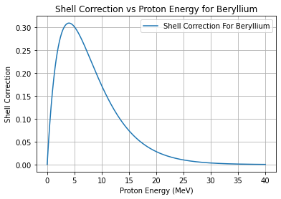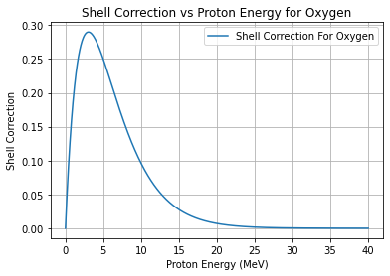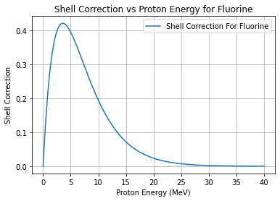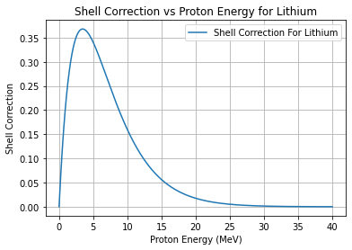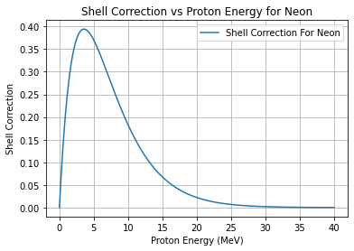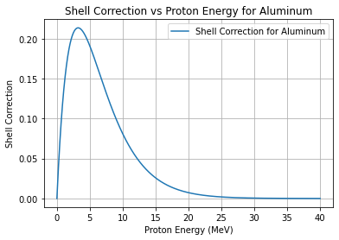
Figure 1: Showing the shell correction factor variation with proton energy for elements such as Beryllium, Oxygen, Fluorine, Lithium, Neon, and Aluminum. Each element exhibits a peak in shell correction near 5 MeV, followed by a decrease at higher energies. These insights are vital for improving proton therapy dosimetry calculations by accurately modeling energy deposition in different materials.
3.2 Analytical Proton Stopping Power Compared with PSTAR Data and SRIM-2008 Data
The stopping power is predicted analytically via mathematical models and equations. The Bethe-Bloch formula, as shown in equation (2), which explains the stopping power of charged particles as they move through matter, is one such concept. Analytical models or Monte Carlo simulations can be used to calculate the proton stopping power, which measures the energy loss of protons per unit route length as they pass through a material. The proton velocity and target material characteristics, such as density and ionization state, affect the stopping power. Despite several assumptions and approximations, the analytical models can yield credible stopping power estimates compared with computed stopping powers (PSTAR, retrieved 2024) and (SRIM-2008, retrieved 2024). We have calculated the stopping powers for various elements and compounds by using the relation provided in equation (2) and accurately applying other empirical equations. The determination of a proton's energy loss per unit distance through a substance is known as the analytical proton stopping power. In fields such as materials science, nuclear physics, and medical physics, this computation is essential. For a given material, the stopping power can be calculated as follows: find the atomic mass (A), atomic number (Z), and mean excitation energy (I) of the material. To find the overall stopping power, the Bethe-Bloch equation (2) is applied, the required adjustments (density and shell effects) are made, and the nuclear and electronic stopping powers are summed.

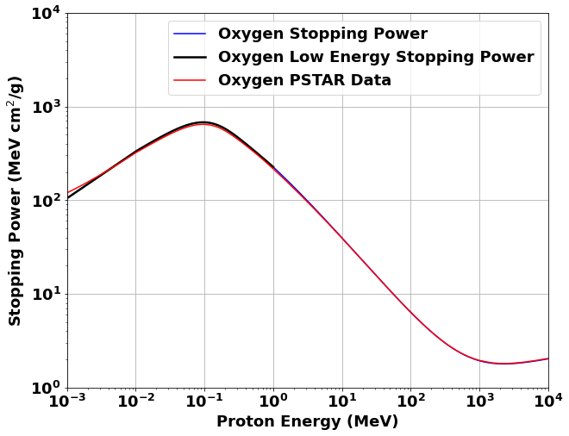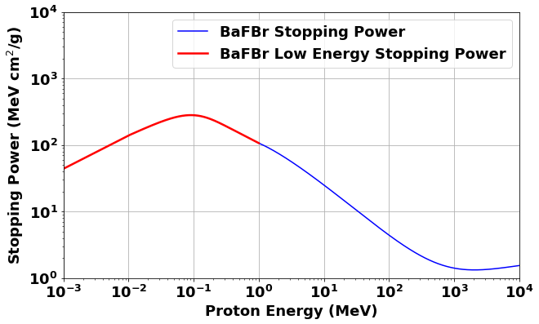

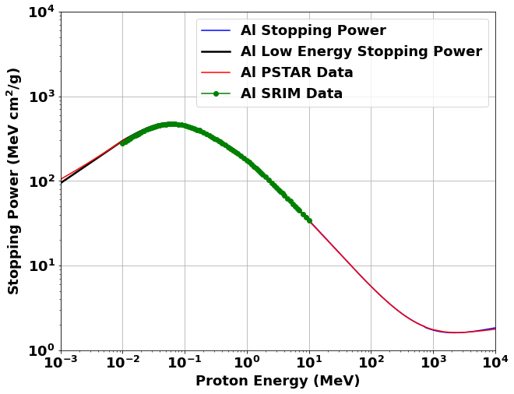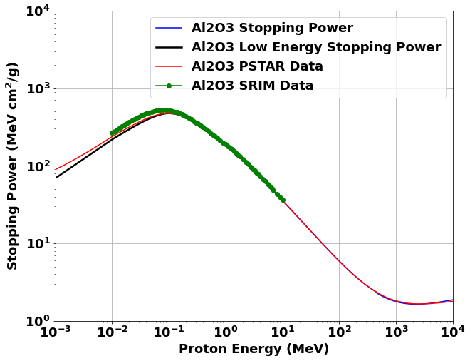

Figure 2: Stopping power analysis for Oxygen, BaFBr, Aluminum, and ${Al}_{2}O_{3}$ across a broad proton energy range. Theoretical models (blue and black curves) align well with computed stopping powers from PSTAR (red curves) and SRIM-2008 (green markers). Minor deviations at lower energies for BaFBr suggest areas for model refinement. This analysis aids in material selection for dosimetry and understanding proton beam interactions.
3.3 Evaluation of the stopping power ratio
The numerical calculation indicates that the water-to-air ratio remains stable, while the ${Al}_{2}O_{3}$-to-water and air-to-water ratios highlight their differing attenuation properties. The BaFBr-to-water ratio shows significant material-dependent differences, and the water-to-${Al}_{2}O_{3}$ ratio is particularly relevant for dosimetry calculations in medical physics which demonstrate consistency across materials but do not inherently confirm the accuracy of LET measurements. The agreement between the computed stopping powers and theoretical values, especially for high-energy protons, confirms the trustworthiness of the Bethe-Bloch theory. There are several important issues and steps in radiation physics and dosimetry that need to be addressed to determine the stopping power ratio. The term “stopping power ratio” is a crucial concept in dosimetry because it relatively compares how different materials stop ionizing radiation with respect to water, which has been used as a standard reference because of its tissue-equivalent properties. For accurate dose estimation as well as treatment planning within the radiation therapy field, it is important to consider this quotient. This formula calculates the stopping powers for both the material under consideration and the reference material on a theoretical basis only; these models incorporate variables such as the mean excitation energy, atomic number, density, etc. Theoretical computations are frequently validated by these empirical values. For protons in a variety of materials, including water, which is frequently used as the reference material, the PSTAR database from NIST offers stopping power and range tables. SPR is used in radiation therapy to translate dose measurements in a phantom substance (often water) into doses in real biological tissues or other materials. Precise SPR values guarantee accurate dosage administration to the intended tissues while preserving the health of nearby healthy tissues. To identify suitable dosimetry materials and create novel dosimetry techniques, SPR can be used to compare the radiological properties of various materials. To view the various energy sources' stopping power ratios by plotting the ratios via the PSTAR water, we determined the SPR for each stopping power of different elements and compounds. An essential step in dosimetry that guarantees precise dose estimation and boosts radiation therapy efficacy is evaluating the stopping power ratio. SPR values for a variety of materials and applications can be achieved with accuracy and reliability by using modern tools such as the computed stopping power from PSTAR, theoretical models, and empirical data.
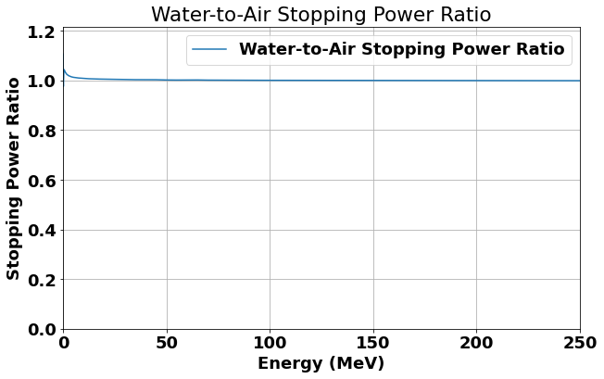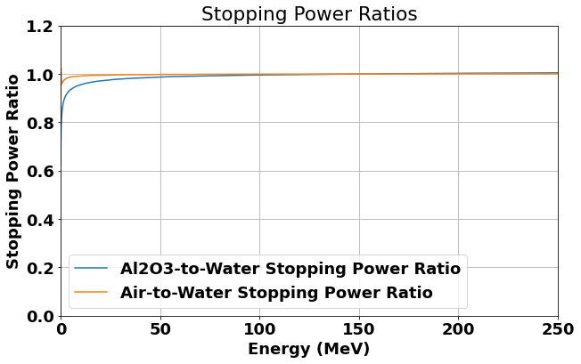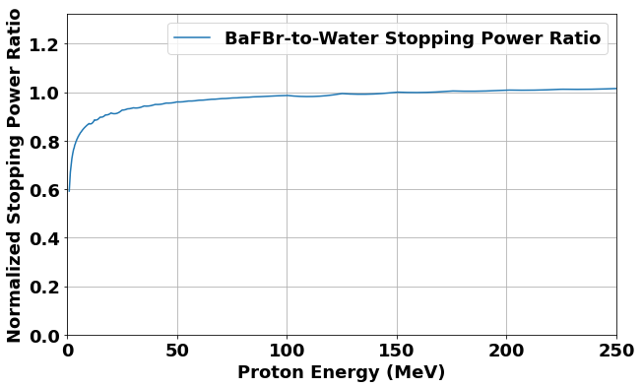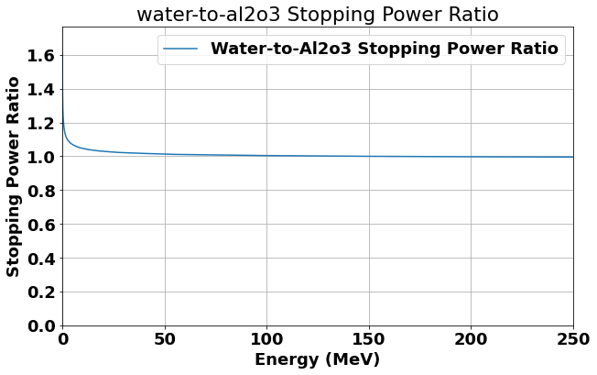
Figure 3: Stopping power ratios for materials like water, air, ${Al}_{2}O_{3}$, and BaFBr over the 0-250 MeV proton energy range. The water-to-air ratio remains stable, while the ${Al}_{2}O_{3}$-to-water and air-to-water ratios highlight their differing attenuation properties. The BaFBr-to-water ratio shows significant material-dependent differences, and the water-to-${Al}_{2}O_{3}$ ratio is particularly relevant for proton therapy dosimetry calculations in medical physics. These ratios are crucial for normalizing dosimetry readings in proton therapy.

4. Discussion
In the present study, we investigated the use of measuring linear energy transfer (LET) in proton therapy by evaluating high-$Z_{eff}$ materials (BaFBr) and low-$Z_{eff}$materials (${Al}_{2}O_{3}$, water). By applying semiempirical models to stopping power ratios for proton energies ranging from 0.01 to 10,000 MeV, we observed that the water-to-air ratio remains stable, while the ${Al}_{2}O_{3}$-to-water and air-to-water ratios highlight their differing attenuation properties. The BaFBr-to-water ratio shows significant material-dependent differences, and the water-to-${Al}_{2}O_{3}$ ratio is particularly relevant for proton therapy dosimetry calculations in medical physics which demonstrate consistency across materials but do not inherently confirm the accuracy of LET measurements.
Our study extends the works of (Setianegara et al., 2021; Setianegara et al., 2020; Zheng et al., 2010; Li et al., 2014; Usta et al., 2017; Amable et al., 2017; Mahmoud et al., 2018; Paul et al. 2013; Trujillo et al., 2019; Akkerman et al., 2001; Akbari et al., 2023) by validating stopping power calculations with the computed stopping powers from SRIM-2008 and PSTAR. We found strong agreement with the results reported in (Setianegara et al., 2021; Setianegara et al., 2020; Sabin and Oddershede, 2009), which demonstrated the utility of high-$Z_{eff}$materials for improved LET sensitivity. This is consistent with (Zullo et al., 2010), who validated water as a standard for LET measurements. However, our results also highlight discrepancies at lower proton energies, indicating potential limitations in current dosimeter techniques. This gap was less emphasized in a previous study (Massillon-JI et al., 2021). This supports the theoretical framework of Bethe-Bloch theory and the semiempirical models used (Setianegara et al., 2021; Setianegara et al., 2020; Zheng et al., 2010).
However, the inconsistencies at lower energies suggest that current dosimetric methods may not fully capture the variations in LET, which is a limitation not fully addressed by earlier research (Massillon-JI et al., 2021). A key strength of our study is the comprehensive comparison of analytical calculations with computed stopping powers from SRIM-2008 and PSTAR, which enhances the robustness of our findings (Sabin and Oddershede, 2009; Amable et al., 2017; Mahmoud et al., 2018) and the normalization of data values at 150 MeV, as suggested by (Setianegara et al., 2021; Setianegara et al., 2020), further validating our results. These limitations include the potential variability in material properties and the reliance on theoretical models, which may not account for all the experimental nuances (Akbari et al., 2023; Yanwen et al., 2009; Amable et al., 2017; Mahmoud et al., 2018).
The findings of this study have significant implications for proton therapy dosimetry calculations, suggesting that high-$Z_{eff}$materials like BaFBr can enhance LET measurement accuracy. This advancement is crucial for improving radiation therapy outcomes because precise LET measurements are essential for effective dosimetry calculations. This finding supports the use of high-$Z_{eff}$materials for LET measurements, and alternative interpretations can consider the impact of measurement errors or variations in material properties. Further exploration of these factors could provide a more nuanced understanding of dosimeter accuracy and its implications for clinical applications.
Integrating more empirical data with theoretical models can also enhance the accuracy of dosimetric assessments and address the discrepancies observed in lower energy ranges for accurate electronic stopping power data (Akbari et al., 2023; Paul et al., 2013; Trujillo-Lopez et al., 2019; Usta et al., 2017; Akkerman et al., 2001). Our results offer valuable insights into the use of various dosimetric materials for LET measurements, which are in excellent agreement with available computed stopping powers and theoretical models reported in the literature. The observed differences between high-$Z_{eff}$and low-$Z_{eff}$materials emphasize the critical role that material selection plays in dosimetry (Setianegara et al., 202; Setianegara et al., 2020; Usta et al., 2017). These insights are expected to guide future research and influence clinical practice by enhancing both radiation therapy and protective measures (Usta et al., 2017). The feasibility and potential clinical benefits of LET-guided IMPT optimization have been investigated, indicating possible improvements in treatment outcomes (Giantsoudi et al., 2013).

5. Limitations and Suggestions for Future Research
This study on dosimeter use for linear energy transfer (LET) measurements in proton therapy identifies several limitations and suggestions for future research. The findings indicate that current dosimeter techniques struggle with accuracy in measuring LET at lower proton energies. Future research should focus on expanding the range of proton energies and exploring additional tissue types to further validate these concepts using experimental confirmation and measurements to reduce uncertainty and refine LET measurement techniques. Integrating more empirical data with theoretical models can also enhance the accuracy of dosimetric assessments and address the discrepancies observed in lower energy ranges for accurate electronic stopping power data. The semiempirical models used in the study showed significant discrepancies in these ranges, highlighting a gap in the existing methodologies. The research emphasizes that the choice of dosimeter materials can significantly impact measurement accuracy. Variations in stopping power ratios across different materials suggest that further exploration of material compositions is necessary to enhance dosimetric precision and there is a need for further improvement of theoretical models used in dosimetry.
This includes refining the empirical relations and correction factors that are essential for accurate stopping power calculations, particularly at low energies. Here, we suggest that integrating more experimental data, especially for complex materials not currently covered with computed stopping powers from PSTAR and SRIM, could enhance the accuracy of stopping power predictions. This would provide a more comprehensive understanding of dosimeter performance across different conditions. Future studies could explore the use of alternative dosimeter materials that may offer better performance in specific energy ranges. Investigating high atomic-number materials alongside low atomic-number materials could yield insights into optimizing dosimeter design for proton therapy. Conducting studies that evaluate the clinical implications of LET-guided intensity-modulated proton therapy (IMPT) optimization could provide valuable insights into treatment outcomes and patient safety. The findings underscore the importance of ongoing research to improve the models used for stopping power calculations and to explore the effects of different material compositions in clinical environments which is essential for advancing the precision. By addressing the limitations identified in this study and pursuing the suggested avenues for future research will be essential for improving dosimetry in proton therapy, ultimately leading to better treatment outcomes for patients.

6. Conclusions
The study successfully validated the stopping power ratios for various dosimetric materials across a wide range of proton energies (0.01 to 10,000 MeV). The results showed strong agreement with computed stopping powers from PSTAR and SRIM-2008, particularly at higher energies (>10 MeV), confirming the reliability of the theoretical models used in the study. Notably, this study identified significant deviations in stopping power calculations at low proton energies (<1 MeV). This finding highlights the limitations of current dosimetric methods, and which suggests a need for improved models to accurately capture LET variations in this energy range. The results indicate that high-atomic number materials, such as BaFBr, can enhance the use of LET measurements in proton therapy. This advancement is crucial for optimizing treatment plans and improving patient outcomes, as precise LET measurements are essential for effective dose delivery. However, further exploration of dosimetric materials and their properties is necessary to address the discrepancies observed, particularly at lower energies. This could lead to the development of more accurate dosimetric techniques that enhance the efficacy of proton therapy.
In conclusion, the findings of this study not only validate the use of high and low-atomic number materials for accurate LET measurements but also underscore the importance of refining dosimetric methods to ensure optimal treatment outcomes in proton therapy.

Declarations
Ethics approval and consent to participate
Not Applicable.
Consent for publication
Not applicable.
Competing interests
There are no competing interests declared by the authors.
Availability of data and materials
Not Applicable.

References
Akbari, F., Taghizadeh, S., Shvydka, D., Sperling, N. N., & Parsai, E. I. (2023). Predicting electronic stopping powers using stacking ensemble machine learning method. Nuclear Instruments and Methods in Physics Research Section B: Beam Interactions With Materials and Atoms, 538, 8-16. https://doi.org/10.1016/j.nimb.2023.02.023
Akkerman, A., Breskin, A., Chechik, R., & Lifshitz, Y. (2001). Calculation of proton stopping power in the region of its maximum value for several organic materials and water. Radiation Physics and Chemistry, 61(3-6), 333-335. https://doi.org/10.1016/S0969-806X(01)00258-4
Alyani Nezhad Z, Geraily G. (2022). A review study on application of gel dosimeters in low energy radiation dosimetry. Appl Radiat Isot. 2022 Jan;179:110015. doi: 10.1016/j.apradiso.2021.110015. Epub 2021 Nov 3. PMID: 34753087.
Amable, A. K. S., Godsway, B. K., Nyaaba, R. A., & Manson, E. N. (2017). A theoretical study of stopping power and range for low energy (< 3.0 meV) protons in aluminium, germanium, lead, gold and copper solid materials. Open Science Journal, 2(2).
Bethe, H. (1933). Handbuch der Physik. In: Geiger, H. and Scheel, K., Eds., Vol. 24, Part 1, Springer, Berlin.
Bichsel H. (1990). Barkas effect and effective charge in the theory of stopping power. Phys Rev A. 1990 Apr 1;41(7):3642-3647. doi: 10.1103/physreva.41.3642. PMID: 9903535.
Christensen JB, Togno M, Bossin L, Pakari OV, Safai S, Yukihara EG. (2022). Improved simultaneous LET and dose measurements in proton therapy. Sci Rep. 2022 May 18;12(1):8262. doi: 10.1038/s41598-022-10575-4. PMID: 35585205; PMCID: PMC9117334.
Driewer JP, Chen H, Osvet A, Low DA, Li HH. (2011). Radiation hardness of the storage phosphor europium doped potassium chloride for radiation therapy dosimetry. Med Phys. 2011 Aug;38(8):4681-8. doi: 10.1118/1.3611043. PMID: 21928642; PMCID: PMC3161504.
Giantsoudi D, Grassberger C, Craft D, Niemierko A, Trofimov A, Paganetti H. (2013). Linear energy transfer-guided optimization in intensity modulated proton therapy: feasibility study and clinical potential. Int J Radiat Oncol Biol Phys. 2013 Sep 1;87(1):216-22. doi: 10.1016/j.ijrobp.2013.05.013. Epub 2013 Jun 19. PMID: 23790771; PMCID: PMC4520412.
Granville DA, Sahoo N, Sawakuchi GO. (2014). Calibration of the Al2O3 optically stimulated luminescence (OSL) signal for linear energy transfer (LET) measurements in therapeutic proton beams. Phys Med Biol. 2014 Aug 7;59(15):4295-310. doi: 10.1088/0031-9155/59/15/4295. Epub 2014 Jul 16. PMID: 25029434.
Han Z, Driewer JP, Zheng Y, Low DA, Li HH. (2009). Quantitative megavoltage radiation therapy dosimetry using the storage phosphor KCl: Eu2+. Med Phys. 2009 Aug;36(8):3748-57. doi: 10.1118/1.3171687. PMID: 19746808; PMCID: PMC2724175.
H. O. Wyckoff (ICRU Scientific Counsellor). “Stopping Powers and Ranges for Protons and Alpha Particles.” International Commission on Radiation Units and Measurements, Bethesda, MD (1993), ICRU-49. Available: https://www.icru.org/report/stopping-powers-and-ranges-for-protons-and-alpha-particles-report-49/
Inaniwa T, Weichert E, Masuda T, Tanaka S, Matsufuji N, Kanematsu N. (2023). Stopping-power ratio of body tissues with updated effective energies and elemental I values for treatment planning of proton therapy and ion beam therapy with helium, carbon, oxygen, and neon ions. Radiol Phys Technol. 2023 Jun;16(2):319-324. doi: 10.1007/s12194-023-00721-6. Epub 2023 Apr 23. PMID: 37087722.
INTERNATIONAL ATOMIC ENERGY AGENCY (2000). Absorbed Dose Determination in External Beam Radiotherapy, Technical Reports Series No. 398, IAEA, Vienna.
J. F. Ziegler. (1999). Stopping of energetic light ions in elemental matter. J. Appl. Phys. 1 February 1999; 85 (3): 1249–1272. https://doi.org/10.1063/1.369844
Li HH, Driewer JP, Han Z, Low DA, Yang D, Xiao Z. (2014). Two-dimensional high spatial-resolution dosimeter using europium doped potassium chloride: a feasibility study. Phys Med Biol. 2014 Apr 21;59(8):1899-909. doi: 10.1088/0031-9155/59/8/1899. Epub 2014 Mar 20. PMID: 24651448; PMCID: PMC4019811.
Liu R, Zhao X, Medrano M. (2022). Experimental validation of proton physics models of Geant4 for calculating stopping power ratio. J Radiol Prot. 2022 Jun 28;42(2):10.1088/1361-6498/ac7918. doi: 10.1088/1361-6498/ac7918. PMID: 35705062; PMCID: PMC9462414.
Mahmoud, M. M., Shakir, I. A., & Sleeman, S. Y. (2018). Shell Correction in Stopping Power for Protons with Different Ionization Degrees in Al2O3 and ZrO2. In IOP Conference Series: Materials Science and Engineering (Vol. 454, No. 1, p. 012019). IOP Publishing.
Massillon-Jl G. (2021). Future directions on low-energy radiation dosimetry. Sci Rep. 2021 May 19;11(1):10569. doi: 10.1038/s41598-021-90152-3. PMID: 34012097; PMCID: PMC8134474.
National Institute of Standards and Technology (NIST). (n.d.). PSTAR: Stopping power and range tables for protons. Retrieved from https://physics.nist.gov/PhysRefData/Star/Text/PSTAR.html
Paul, H., & Sánchez-Parcerisa, D. (2013). A critical overview of recent stopping power programs for positive ions in solid elements. Nuclear Instruments and Methods in Physics Research Section B: Beam Interactions With Materials and Atoms, 312, 110-117. https://doi.org/10.1016/j.nimb.2013.07.012
Sabin, J. R., & Oddershede, J. (1982). Shell corrections to electronic stopping powers from orbital mean excitation energies. Physical Review A, 26(6), 3209.
Sabin, J. R., & Oddershede, J. (2009). An analytical representation of shell corrections for stopping power. International Journal of Quantum Chemistry, 109(13), 2933-2936. https://doi.org/10.1002/qua.22126
Setianegara J, Mazur TR, Maraghechi B, Darafsheh A, Yang D, Zhao T, Li HH. (2020). Quantitative proton radiation therapy dosimetry using the storage phosphor europium-doped potassium chloride. Med Phys. 2020 Oct;47(10):5287-5300. doi: 10.1002/mp.14423. Epub 2020 Aug 16. PMID: 32750155.
Setianegara J, Mazur TR, Yang D, Li HH. (2021). Dual-storage phosphor proton therapy dosimetry: Simultaneous quantification of dose and linear energy transfer. Med Phys. 2021 Apr;48(4):1941.
SRIM. (2008). SRIM - The Stopping and Range of Ions in Matter. Retrieved July 12, 2024, from http://www.srim.org/SRIM/SRIMLEGL.htm
Sternheimer, R., Berger, M., & Seltzer, S. (1984). Density effect for the ionization loss of charged particles in various substances. Atomic Data and Nuclear Data Tables, 30(2), 261-271. https://doi.org/10.1016/0092-640X(84)90002-0
Trujillo-López, L., & Cabrera-Trujillo, R. (2019). Electronic stopping cross section for protons incident on biological and biomedical materials within a FSGO quantum chemistry description. Radiation Physics and Chemistry, 156, 150-158. https://doi.org/10.1016/j.radphyschem.2018.10.013
Usta, M., & Tufan, M. Ç. (2017). Stopping power and range calculations in human tissues by using the Hartree-Fock-Roothaan wave functions. Radiation Physics and Chemistry, 140, 43-50. https://doi.org/10.1016/j.radphyschem.2017.03.005
Woody, C L. A summary of radiation damage studies in barium fluoride from the GEM Collaboration. United States.
Xu, X., Xie, Y., Zhao, M. et al. Investigation on Accuracy of Stopping Power Ratio Prediction Based on Spectral CT. J. Med. Biol. Eng. 42, 845–852 (2022). https://doi.org/10.1007/s40846-022-00761-0
Yanwen Zhang, In-Tae Bae, Kai Sun, Chongmin Wang, Manabu Ishimaru, Zihua Zhu, Weilin Jiang, William J. Weber; Damage profile and ion distribution of slow heavy ions in compounds. J. Appl. Phys. 15 May 2009; 105 (10): 104901. https://doi.org/10.1063/1.3118582
Zullo, J. R., Kudchadker, R. J., Zhu, X. R., Sahoo, N., & Gillin, M. T. (2010). LiF TLD-100 as a dosimeter in high energy proton beam therapy—can it yield accurate results?. Medical Dosimetry, 35(1), 63-66.

Zheng Y, Han Z, Driewer JP, Low DA, Li HH. Theoretical and empirical investigations of KCl : Eu2+ for nearly water-equivalent radiotherapy dosimetry. Med Phys. 2010 Jan;37(1):146-53. doi: 10.1118/1.3271338. PMID: 20175476; PMCID: PMC2801734.

